Total Score
_______ / 50 points
A  [Track 08] Listen to Emma and Paul talk about an article in a magazine. Write T (true) or F (false).
1. The article says that optimistic people are always outgoing. ____
2. Paul agrees with the writer’s ideas about optimistic people. ____
3. Emma doesn’t think Paul is easygoing. ____
4. Paul thinks that Emma is very considerate. ____
5. Paul wants to learn more about the writer’s ideas. ____
A _______ / 10 points (2 points each)
B Circle the correct adjective to complete each sentence.
1. The soup is hot! Please be fair / careful / indecisive.
2. She’s honest / unfair / adventurous. If she doesn’t like something, she tells you.
3. My son is very unreliable / agreeable / curious. He’s always asking questions.
4. William is very stubborn / unfair / unreliable. He never lets me help him.
5. Lenny is patient / agreeable / ambitious. He got two promotions last year, and he
hopes to get a third one soon.
6. Don’t be so reliable / indecisive / considerate. Do you want to marry her or not?
B _______ / 6 points (1 point each)
C Complete each sentence with the correct present perfect form of the verb in parentheses and since or for.
1. We _____haven’t lived______________ (not / live) in Canada ____since_____________ a long time.
2. My friend ___has studied_______________________ (study) Chinese __since_______________ 2007.
¹
²
3. He ____has been______________________ (be) in Mexico ______for___________ a month.
³
⁴
4. I ____haven’t seen______________________ (not / see) her _____since____________ this morning.
⁵
⁶
5. She ___hasn’t written_______________ (not / write) to me ___since______________ she went to Japan.
⁷
⁸
C _______ / 10 points (1 point each)
¹⁰
⁹

D Rewrite each sentence with the adverb in parentheses in the correct place.
1. Eve is intelligent. (extremely)
__ Eve is extremely intelligent. _________________________
2. I finished my homework. (quickly)
_ I finished my homework quickly. _______________
3. Dinner tonight was good. (really)
__ Dinner tonight was really good. _________________________
4. They speak English. (well)
__ They speak English well. ________________________________
5. Do you learn new things? (easily)
__ Do you learn new things easily? ___________________________
6. The test was easy. (fairly)
__The test was fairly easy.
D _______ / 6 points (1 point each)
E Number the lines of the conversation in the correct order.
___3_ A: You may be right. I said I liked her hair longer. Now she feels
terrible, and so do I.
___6_ B: Yes, it’s very short. She asked me what I thought, and I told
her I loved it.
__2__ B: See? Sometimes honesty isn’t the best policy.
_4___ B: Actually, I don’t. But in my opinion, it’s better to say something
nice so the other person feels good. Don’t you think so?
__1__ A: Have you seen Kim this week? She cut her hair short.
__5__ A: Is that true? Do you really think she looks good with short hair?
E _______ / 6 points (1 point each)

F Read the article. Check () the correct answer for each question.
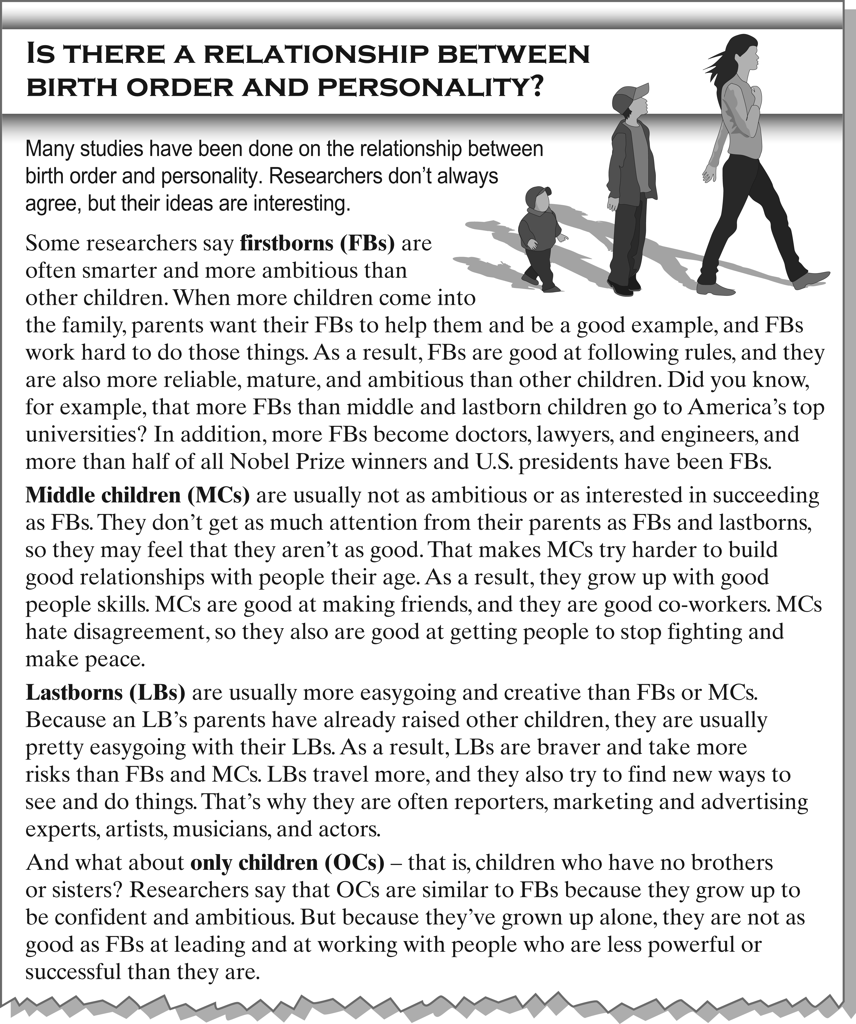
Which children . . . ? | FBs | MCs | LBs | OCs
1. are not afraid to do things differently |  |  |  | 
2. might be successful, but may not be a nice boss |  |  |  | 
3. are often less confident than the others |  |  |  | 
4. may make the best politicians and scientists |  |  |  | 
5. try hard to make other people agree |  |  |  | 
6. are parents more relaxed with |  |  |  | 
F _______ / 12 points (2 points each)

